**WG III Contribution to the IPCC AR6 report – Summary for Policy Makers**

**(Draft V1.0 _ 5-06-2020)**

Section A - Introduction

***INTERNAL note on section scope:***

*Actions to mitigate climate change take place in the context of sustainable development and efforts to achieve the sustainable Development Goals (SDGs). Greenhouse gas emissions are closely tied to the development pathways followed by all countries, whatever their development status. The literature assessed in this report views the mitigation challenge through a number of lenses including sustainable development, equity, risk, costs and benefits, and socio-technical transitions.* *Delaying climate action will make achieving climate goals more difficult to reach or even beyond reach.*

This section has two purpose: a) to set out the principal framings for the report based largely on Chapter 1; and b) to set out some basic housekeeping e.g. literature cut-off, approach to confidence and role in the AR6 cycle. Given its nature, we have suggested not using the headline statement format but rather flowing text. It introduces the SPM by: noting the context for the report; what is new since AR5/SRs; key framings for the report including sustainable development; “urgency” (stated non-prescriptively), and brief summary of formal approaches to uncertainty and traceability (line of sight/confidence).

The Working Group III (WG III) contribution to the IPCC’s Sixth Assessment Report (AR6) assesses literature on the scientific, technological, environmental, economic and social aspects of mitigation of climate change. It builds upon the WG III contribution to the IPCC’s Fifth Assessment Report (AR5), and the three Special Reports in the sixth assessment cycle[1]. This report incorporates subsequent new findings and provides an updated assessment of the current state of knowledge[2].

This report reflects the multiplicity of approaches that can be used to obtain insights, including from models, top-down and bottom-up analysis, scenario frameworks, cost-benefits, treatment of uncertainty, risk assessment, data, and social science framings. Common framings on climate change mitigation used within the literature since AR5 include economic, ethical and transitional theories and perspectives. The literature increasingly combines these theories and perspectives to explore ways to accelerate action on climate mitigation. {1}

A central framing of this report is an integrative perspective on climate change responses and sustainable development, in relation to the Agenda for Development 2030 and beyond. Since AR5, the literature on global and regional mitigation pathways has highlighted a strong dependence of attainability of stringent climate goals and the associated costs of mitigation on the underlying development pathway. The literature reflects how situating climate change mitigation in the context of sustainable development can facilitate and accelerate action whilst considering equity and efforts to eradicate poverty. {1}

The literature since AR5 has developed in the context of the Paris Agreement and climate action taken at the national level. It identifies response options available in the near-term that can address both climate change adaptation and mitigation. It also identifies co-benefits and risks linked to sustainable development. The literature shows that delaying climate mitigation and adaptation actions would limit future choices and reduce the prospect of following sustainable development pathways. {1}

This Summary for Policymakers (SPM) is structured in five parts, A: Introduction and framing, B: Where we are now and where we are headed, C: System transformations to limit global warming, D: Mitigation, adaptation and sustainable development, E: Strengthening the response. The basis for the SPM can be found in the chapter sections of the underlying report and in the Technical Summary (TS). References to these are given in square brackets.

Confidence in key findings is indicated using the IPCC calibrated language[3].

SECTION B: Where are we now and where are we headed?

***INTERNAL note on scope of section:***

*Global emissions of greenhouse gases continue to rise although the rate of growth has fallen since 20xx. The main drivers are rising affluence, reflected in emissions embodied in international trade, and to a lesser extent population. Some decoupling of emissions and GDP has occurred but the extent varies from one region to another. Some future emissions are unavoidable because of past infrastructure investment and embedded practices. Current national commitments are in aggregate consistent with long-term pathways resulting in global warming of 2.x/3.y°C during the 21st century, but have brought projected emissions below business-as-usual levels. Since AR5, opportunities, actions and plans that can reduce emissions and enhance sinks have become evident across all sectors and systems but are not yet supported by consistent policies to deliver on those targets. Nonetheless, new policies and institutional arrangements have contributed to the take-up of mitigation actions at sub-national, national and regional to global scales.*

This sectiondoes what the title suggests.A quantitative re-cap of emissions and drivers, what national commitments could achieve and a quantification of lock-in comes first. The remainder is more qualitative, summarising what has changed since AR5 across four cross-cutting topics, each of which gets a Headline Statement: national and sub-national policies; international cooperation; finance; and technology. Before the cross-cutting topics, there is a single Headline Statement covering sectors, with sperate sub-statements for each. Finance is included here as a sector as well as a cross-cutting topic.

**B.1 Global greenhouse gas (GHG) emissions have continued to rise in [all/most sectors] since AR5 although the rate of growth has fallen since 20xx, especially in […]. *(xxx confidence*) {2}**

**[CH LEAD: 2]**

B.1.1 Global GHG emissions were likely 58 (±5.8) GtCO2eq in 2018, the highest in human history. Global emissions have flattened since 201x, but have grown by [xx]% since 1990 and [yy]% since 2000. Cumulative emissions from the pre-industrial period to 2018 are [zzzz] *(xxx confidence).* {2}

B.1.2 In 2018, CO2 emissions from fossil fuel and industry (FFI) were 38 (± 3.0) Gt, CO2 from AFOLU 5.5 (± 2.8) Gt, CH4 11 (± 2.2) Gt CO2eq, N2O 2.5 (± 1.5) GtCO2eq and F-gases 1.6 (± 0.32) GtCO2eq. While CO2 emissions from FFI have grown by 66% (since xxxx), emission growth was only 24% and 28% for CH4 and N2O *(xxx confidence)*. {2}

B.1.3 Despite having lower per capita emissions, developing countries accounted for [xx%] of global CO2 emissions growth after 2008, mostly driven by increased consumption and investment *(robust evidence, high agreement).* {2}

B.1.4 Consumption-based CO2 emissions in developed economies are considerably higher than in developing economies (*high confidence*). Consumption-based CO2 emissions in developed economies reached a peak of [17 Gt] in 2007 with a subsequent 10% decline by 2015. Yet, with [46%] of global emissions, this group was still the largest contributor from a consumption perspective, compared to [41%] from developing economies, and less than 1% from least developed ones. This is due to net CO2 emission transfer from developing to developed countries via global trade chains (*robust evidence, high agreement*). {2}

B.1.5 GHG emissions have peaked in several countries, but in no country does the current annual average rate of decline [over a sufficiently long recent period] match the sustained decline rates over the next 2-3 decades in global emission scenarios that limit warming to well below 2°C *(xxx confidence)*. {2}

B.1.6 [*A statement based on sectoral emissions - important to pull out land-based to compensate for energy bias in these statements.]*

B.1.7 A decomposition analysis of recent emission trends shows that growing affluence has been the strongest driver of CO2 emissions from fossil fuel combustion, followed by population (*robust evidence, high agreement*). Emissions are decoupled from economic growth due to improved energy efficiency and a switch to lower carbon energy sources *(xxx confidence)*.{2}.

**FIGURE SPM XXX**: *[Candidate figure(s) to support these statements, including a new one on Kaya:]*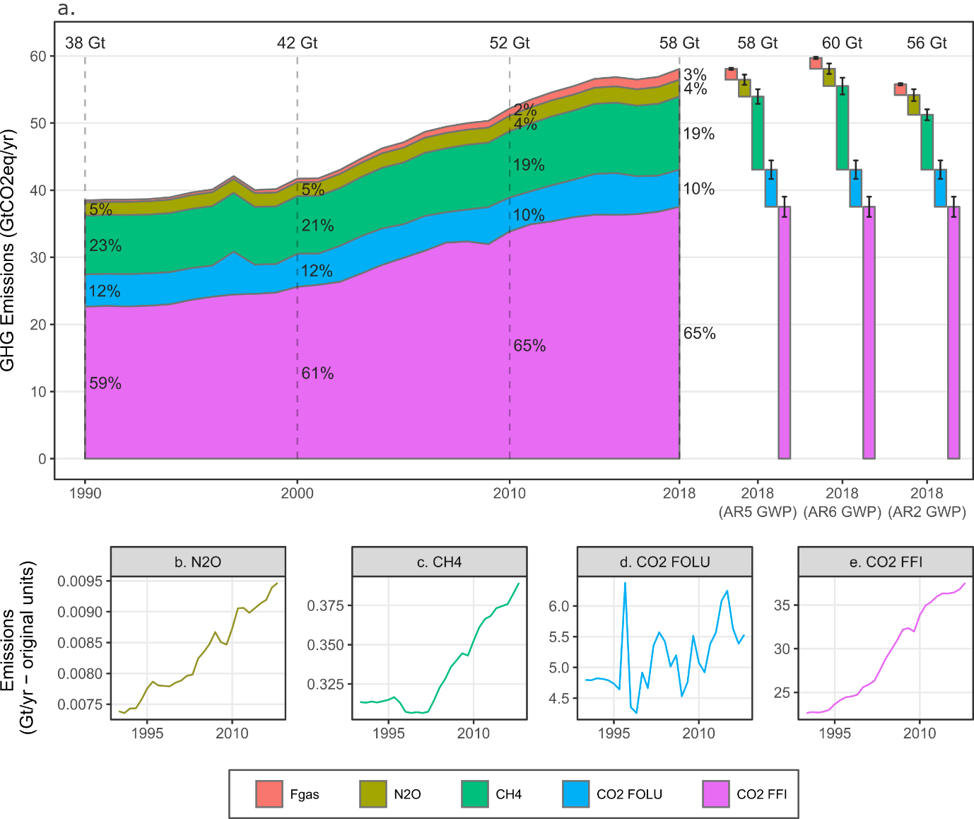

SPM FIGURE XXX *[CH LEAD: 2]*

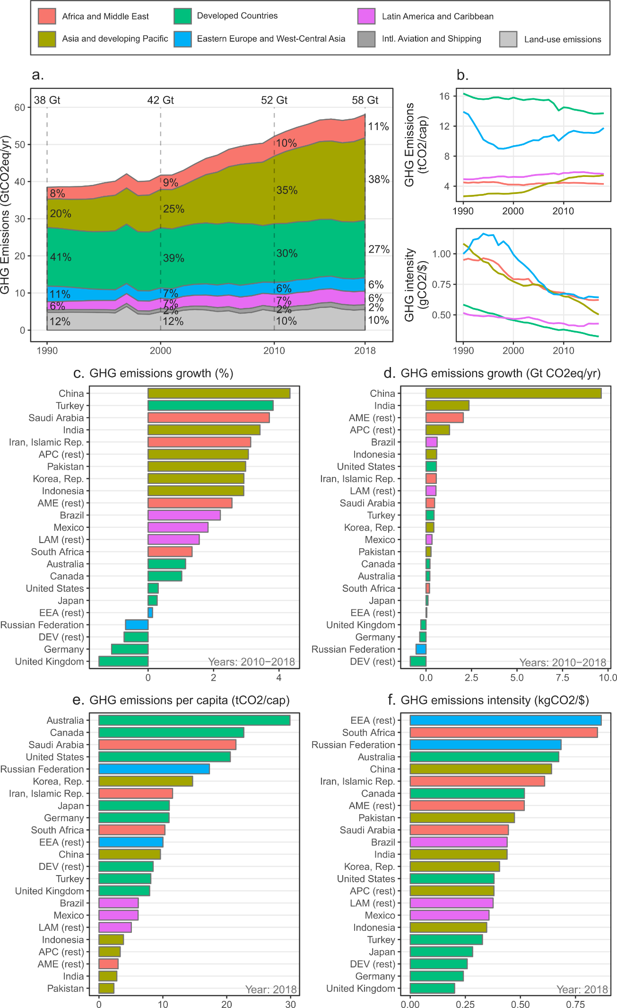

SPM FIGURE XXX[*CH LEAD: 2]*

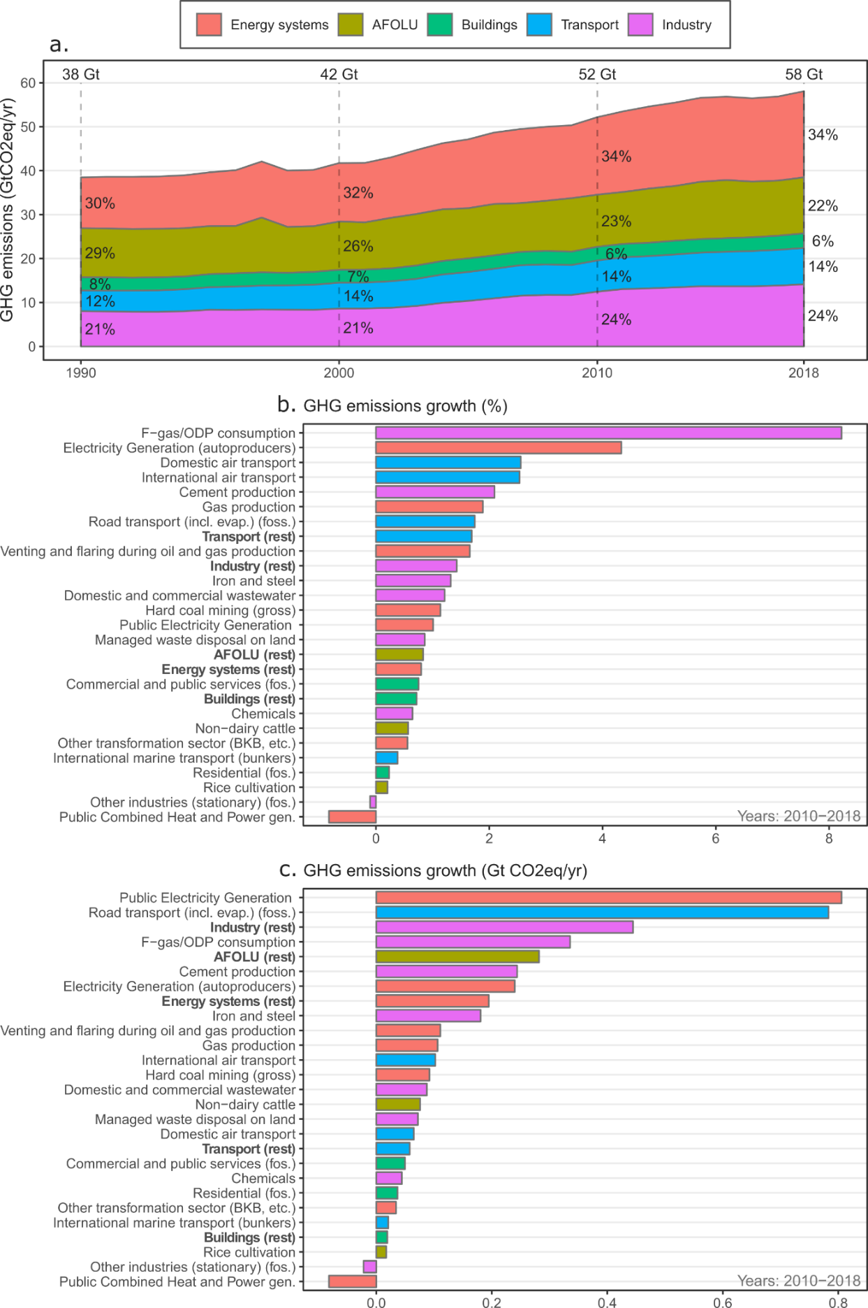

SPM FIGURE XXX *[CH LEAD: 2]*

**B.2 Current national commitments have brought projected aggregate global emissions below the levels associated with the implementation of current policies. Current commitments for 2030 are not in aggregate consistent with long-term pathways that will limit global warming to less than 2°C during the 21st century *(xxx confidence)*. {4}**

**[CH LEAD: 4]**

B.2.1 Current policies lead to median global GHG emissions of 60 GtCO2eq with a full range of 57–65 by 2030 and unconditional and conditional NDCs to 56 (54–62) and 52 (49–56) GtCO2-eq, respectively (*medium evidence, high agreement*). {4}

B.2.2 Current GHG emission trends at the global level and the mitigation investments expected by 2030 are not compatible with the long-term temperature goal in the Paris Agreement even when a broad range of potential rapid reductions in emissions after 2030 is considered *(xxx confidence).* {1, 3}.

B.2.3 The comparison of unconditional NDCs and cost-effective long-term mitigation pathways gives rise to a 2030 emissions gap of 28–34 GtCO2eq for limiting warming to 1.5°C, and 11–16 GtCO2eq for limiting warming to 2°C. Meanwhile, the comparison of conditional NDCs and cost-effective long-term mitigation pathways gives rise to a 2030 emissions gap of 23–29 GtCO2eq for limiting warming to 1.5°C, and 6–10 GtCO2eq for limiting warming to 2°C. *(xxx confidence)* {4}

B.2.4 In mitigation pathways that close the emissions gap consistent with limiting warming to 1.5°C (2°C), renewable energy supply is scaled up by a factor of yy–yy (yy–yy) by 2030 compared to today while efficiency measures and behavioral change reduce energy demand across all sectors by xx–xx% (xx–xxx%). In scenarios that limit average global temperature change to below 1.5°C, the investment needs into mitigation actions are about [USD xx billion] by 2030, and increase further to [USD xx trillion] by 2050. (*xxx confidence)* {3}

**SPM FIGURE XXX** *[Candidate Figure. Figure from the Cross-Chapter Box 1 between Ch3 and Ch4 comparison of projects of global GHG emissions that would emerge from the implementation of current policies and NDCs, illustrating emission gap] {CH LEAD: 4}*

**B.3 Some future CO2 emissions are unavoidable because of committed emissions associated with current and planned infrastructure and investments, institutional inertia and social norms *(high confidence)*. {2}**

**[CH LEAD: 2]**

B.3.1 Assuming continued historical retirement rates and capacity utilization, estimates of future CO2 emission commitments from current energy infrastructures vary between 660 and 720 GtCO2. Accounting for energy infrastructure proposals in addition, future CO2 commitments of 850 [range] GtCO2 fill up the remaining carbon budget for keeping warming well below 2°C and exceed the remaining carbon budget for 1.5°C *(xxx confidence)*. *{Ch?}*

B.3.2 Scenarios that limit warming to well 2°C or 1.5°C involve early retirement of fossil energy infrastructures, particularly those linked to coal *(xxx confidence*). {2.8.2}

B.3.3 Factors limiting ambitious transformation include structural barriers, inertia, and both ‘hard’ lock-in (like infrastructure and assets) and ‘soft’ lock-in (political economy, regulatory inertia and vested interests). The interaction between power, politics and economy is central in explaining why broad commitment does not always translate to urgent action in states and beyond. {1} *(xxx confidence)*

B.3.4 *[Institutions and behavioral norms: Current trends show the potential of demand-side solutions, but also that this potential is underutilized {5}].*

**B.4 Since AR5, many countries have developed cross-cutting climate policy frameworks and institutional arrangements. Gaps remain between the ambition of climate commitments and their effective implementation which can be attributed to the lack of sufficient policies and suitable institutions (*xxx confidence).*** **{13}**

**[CH LEAD: 13]**

B.4.1 [*Quantitative statement about the spread of climate legislation, national strategies, carbon pricing etc {13}]*

B.4.2 Climate mitigation is increasingly being undertaken by a diverse set of actors going well beyond national governments, including cities, states/provinces, businesses, and citizens themselves (*xxx confidence)*. {6}

B.4.3 Subnational actors are playing crucial mitigation roles in developing, delivering and contesting mitigation policies for several reasons: They are the level where the impacts of climate change are felt, and often they have remit over land use planning, waste management, infrastructure, and community development *(xxx confidence)*. {13}

B.4.4 Many national and subnational actors are not equipped with the capacities needed to mobilize financial and human resources, build coalitions, facilitate coordination, develop relationships across old and new organizations, and create new competences at both the individual and institutional level (*xxx confidence)*. {13}

B.4.5 Industry has not so far been as affected by climate policy as other sectors due to international competition and specific safeguards (e.g. free allocation of emission permits) have been implemented to avoid the risk of carbon leakage (*xxx confidence)*. {11} *[More on other sectors is needed]*

B.4.6 *[Placeholder statement on carbon disclosure. A statement about the distinct absence of climate policies in some sectors (existing mitigation potential has remained untapped; e.g. agriculture)]*

B.4.7 Demand-side policy success stories have been demonstrated in multiple service categories and in many countries *(xxx confidence).* {5} *[Elaborate on success stories]*

**SPM Figure XXX** *[Candidate Figure suggested by Ch13: 2x2 Figure mapping landscape of climate-development actions - qualitative empirical figure].*

**B.5 In all sectors, there have been developments since AR5 which have limited GHG emissions below previously projected levels, or which have the potential to limit future emission reductions, reflecting the relevance of [technology, policies, behavior, …]** *(****xxx confidence).***

**[CH LEAD: 12]**

B.5.1 Electricity generation from low-carbon sources, particularly wind and solar power, has increased substantially in recent years. While substantial, this growth is well below what would be needed to meet the Paris goals. From 2013 to 2017, generation from low-carbon electricity has increased by 23%. The vast majority of the growth has been solar PV and wind power, which have grown by 217% and 74%. Growth in hydropower (7%), nuclear power (6%), and CCUS has been limited. (*xxx confidence)*. {6}

B.5.2 Climate change, increasing population, urbanization, welfare, and aspirations for wellbeing for all, will continue to drive energy demand in buildings, especially for cooling and digitalization *(xxx confidence)*. {9}

B.5.3 Since AR5, technological change in the transport sector has begun to show a widening gap in the future mitigation potential between land-based systems and those for shipping and aviation. Land-based systems offer strong mitigative capacity due to the dramatic growth in solar and wind power with an associated growth in Li-ion batteries providing cost effective electro-mobility. Meanwhile, shipping and aviation offer a less competitive mitigation option due to less development around fuels (e.g. hydrogen and biofuels). *(xxx confidence)* {10}

B.5.4 Emissions from industry have increased faster than emissions in any other sector since 2000, driven by increased basic materials extraction and processing. Global energy intensity is decreasing but global materials intensity is increasing with in-use stock growing faster than GDP since 2000 (*xxx confidence)*. {11}

B.5.5 [*Statement on* *Finance sector: what has happened to climate finance. e.g., Financial Stability Board]*

**B.6 The role of international cooperation has changed, but not diminished, since AR5. There has been a shift from multi-lateral standard setting and enforcement to enabling and strengthening national action and regional cooperation (*high agreement, robust evidence*).**

**[CH LEAD: 14]**

B.6.1 *[Paris Agreement, including all three goals (temperature, adaptation, finance)]*

B.6.2 *[ICAO and IMO]*

B.6.3 *[Other sectoral agreements; technology cooperation/transfer agreements Bilateral/plurilateral cooperation agreements]*

**B.7 Climate financing needs have increased compared to AR5 levels driven by shorter period remaining until 2050/2030, relatively low mitigation investment activity in the past several years and rising levels of adaptation costs and linked to climate-related extreme events. Average annual mitigation investments required come in between [xx–yy] trillion USD for 2020–2030 with annual adaptation action expected to add between [xx–yy] trillion USD *(xxx confidence)*. *{15}***

**[CH LEAD: 15]**

B.7.1 Climate-related pledges, commitments and risk management by investors and finance providers, both public and private, do not necessarily result in climate mitigation and adaptation action/results on the ground *(xxx confidence)*. {15} *[Elaborate with more empirical inputs]*

B.7.2 Macroeconomic headwinds including unstable and slowing global GDP growth, larger prospective fiscal costs of climate shocks, rising financial and insurance sector stresses and losses, politically increasingly infeasible carbon taxes, and near-term economic slowdown some of which may be exacerbated by the effects of Covid-19 *(xxx confidence)*. {15} *[Elaborate with implication on mitigation]*

B.7.3 Private sector climate finance has outpaced public climate finance in recent years with the total still remaining far below required levels. Lack of adequate public climate finance, including international public finance, risks a slow redirection of private finance and the transformations in sectors with limited private sector activity *(xxx confidence)*. {15}

B.7.4 The climate finance gap is widening with the gap having increased roughly by xxx% from an estimate of xxx to xxx in the last [5] years [*or since the last AR5 assessment*]. *(xxx confidence)* {15} *[More on sectors and regions]*

B.7.5 Climate related financial risk arising from physical impact of climate change and a disorderly transition to a low carbon economy due to delayed action is considerably underestimated by financial institutions and markets. This results in investments inconsistent with both adaptation and mitigation objectives. It can also lead to missing the time window for the transition and failing to achieve the climate goals of PA. (*xxx confidence)*. *{15}*

B.7.6 Two-thirds of the expected low-carbon investments required to meet [2°C] are in developing countries, while the bulk (80%) of financial assets, and many leading decision-makers are located in developed country markets. The delay in redirecting cross-borders climate finance flows can exacerbate the carbon lock-in of emerging countries *(xxx confidence)*. {15} *[Focus on near term investments needs]*

**B.8 Many individual technologies have shown rapid progress since AR5 in terms of cost, performance and adoption (*robust evidence, high agreement*). Cross-cutting technological change, notably digitalization, has had far-reaching impacts on mitigation opportunities and potential across all sectors. Nonetheless, there remains a substantial gap between the current patterns and rates of technological change and what is needed to achieve climate and sustainable development goals.** **{2}**

**[CH LEAD: 16]**

B.8.1 Advances in technologies, including transformative changes in some regions and sectors, has opened up new and large-scale opportunities for deep decarbonization, and for alternative development pathways, which could deliver multiple social and developmental goals *(xxx confidence)*. {1} [*Examples of successes (digitalization, batteries)]*

B.8.2 *[Gap between the current patterns of technological change and what is needed to achieve climate and sustainable development goals. Example: slow progress (CCS); uneven rate of penetration in different regions; energy access] {16}*

B.8.3 Many governments are strengthening innovation processes by adopting holistic perspectives. *[Elaborate on international collaboration on technology]* {16}

Section C: System transformations to limit global warming

***INTERNAL note on scope of section:***

*Revised estimates of warming associated with a given emissions scenario since AR5 mean that only a handful of published mitigation pathways are now compatible with limiting global warming to 1.5°C, even allowing for overshoot. As a result, remaining carbon budgets to 1.5°C (and higher levels of warming) are smaller than previously estimated in AR5 and the Special Report on Global Warming of 1.5°C. This means even more rapid and pervasive system changes are required over the next few decades. A central projection based on current national commitments suggests that global warming of 1.5°C will be exceeded by 203x. Opportunities to reduce emissions and enhance sinks are numerous and include inter alia net zero energy systems, energy efficiency, electrification of energy demand, afforestation, agricultural intensification, sustainable cities and carbon dioxide removal. Delays to action could place limiting global warming to 1.5°C, or even 2°C, increasingly beyond reach.*

This section has two main components: a) to assess global emissions pathways in the context of different warming levels including those indicated in the Paris Agreement long-term temperature goal; and b) to identify transitions at the system and sectoral level that would limit warming (it would also be possible to split this into two sections).

The first three bullets address emission/mitigation pathways, illustrative pathways, carbon budgets/net zero drawing largely on Chapter 3. This depends on the development of thinking about illustrative pathways, engagement with WG I on carbon budgets and the availability of new scenarios. The second part is essentially a deep dive into response options – from a techno-economic perspective – at the sectoral level. A specific Headline Statement on the demand side is suggested. The precise scope of each system/sectoral Headline Statement would depend on the availability of material (e.g. combining transport and settlements).

**C.1** **Mitigation pathways describe warming levels that range from less than 1.5°C peak warming over the 21st century to greater than 4.5**°**C warming by 2100, depending on the strength and timing of the mitigation policies applied. Weaker near-term action makes achieving the Paris Agreement temperature goal increasingly implausible as it would entail assumptions about accelerated technology and policy development and deployment not found in the assessed literature and inconsistent with current evidence and projections (*xxx confidence*). {3}**

**[CH LEAD: 3]**

C.1.1 In the absence of new climate policies (meaning non-implementation of NDCs and even including a failure to implement current policies), annual GHG emissions may increase from [XX] to 65–95 GtCO2eq yr-1 by 2050, resulting in a global average temperature change of 3.5 to 4.5°C by 2100 (*xxx confidence*). {3}

C.1.2 Most pathways achieving mitigation levels below 3.0°C by 2100 peak GHG emissions at some point before the end of the 21st century. Pathways describing the most ambitious level of mitigation, and most stringent policies consistent with the temperature goal of the PA typically lead to a GHG emissions peak before 2030. Few pathways in the literature are compatible with <1.5°C without some level of temporary temperature overshoot during the course of the 21st century (*xxx confidence*). {3}

C.1.3 Mitigation pathways consistent with limiting temperature change to “well below 2°C” are typically associated with GHG emissions of 30–50 GtCO2eq yr-1 by 2030 and 5–25 GtCO2eq yr-1 by 2050. This corresponds to global GHG emissions reductions of 0–40% by 2030, and 55–90% by 2050 (relative to 2018 emissions levels). Pathways that aim at limiting temperature to below 1.5°C require a further acceleration of the pace of the transformation, with GHG emissions reductions of about 50–70% by 2030 and 70–100% in 2050 (relative to 2018) (*xxx confidence*). {3}

C.1.4 For CO2 emissions, a warming limit of 1.5°C (at >50% probability of staying below) with no or low (< 0.1°C) temporary overshoot of the limit implies emitting less than 30 GtCO2 in 2030. A warming limit of 2°C (at 50% probability) implies emitting less than 30 GtCO2 in 2030. (At 66% probability of staying below the 2°C limit, this implies emitting less than 40 GtCO2 in 2030.) (*xxx confidence*). {3}

**BOX SPM XXX.***[Suggested Box on Net Zero & Carbon Budgets (max half page)]* [*CH LEAD: 3]*

**C.2** **The timing of carbon neutrality is the main determinant for the timing of the temperature peak over the 21st century. The height of the temperature peak is primarily determined by the quantity of carbon emitted before neutrality is achieved. Remaining carbon budgets (toward a given level of peak warming) therefore influence the pace of required emissions reductions. {3}**

**[CH LEAD: 3]**

C.2.1 Data from modeled emissions pathways show that there is a clear relationship between the temperature target, the year that emissions reach zero globally, and the global carbon budget (*xxx confidence*). {3}

C.2.2 A temperature target of below 3.0°C (category C6) corresponds approximately to reaching net-zero emissions by the end of the century and a roughly 3,000 GtCO2 carbon budget (*xxx confidence*). {3}

C.2.3 A below 2.0°C (category C4) or well below 2.0°C (category C3) target meanwhile corresponds to a larger range of years for carbon neutrality (around 2050–2080) and carbon budgets (from 2016 to 2100) of around 1100 and 800 GtCO2, respectively (*xxx confidence*). {3}

C.2.4 A <1.5C target with either high or low overshoot requires carbon neutrality before 2050 and carbon budgets (from 2016 to 2100) of around 200 GtCO2 (*xxx confidence*). {3}

C.2.5 In the well below 2.0°C and <1.5°C pathways, carbon budgets up until the year carbon neutrality is reached are considerably higher than the budgets to 2100, owing to carbon dioxide removal (CDR) technologies being deployed (*xxx confidence*). {3}

C.2.6 For total GHGs, similar trends can be found, though the net-zero emissions year is typically around 20 years later (*xxx confidence*). {3}

**C.3 Pathways describing rapid and extensive mitigation in the near term entail rapid decarbonization of the electric sector, increased service-demand efficiencies within the end-use sectors (transport, buildings, industry), and much greater deployment of low-carbon fuels (electricity, hydrogen, biofuels). Many of these pathways also entail negative emissions from the AFOLU sector and CDR. *(xxx confidence)* {3}**

**[CH LEAD: 3]**

C.3.1 The illustrative pathways (IPs) describe archetypical routes toward different temperature goals relying on alternative sets of mitigation options; the IPs thus highlight trade-offs between different mitigation and policy choices (*xxx confidence*). {3} *[Add key insights from IPs along the dimensions that differentiate them: temperature targets, timing, mitigation options employed, SDG linkages]*

C.3.2 Accelerated mitigation pathways describe rapid and extensive mitigation in the near term, moving from current trends onto a 1.5°C or well below 2°C pathway over the next decade and then fall below NDC-consistent emission levels in 2030 by around 10 GtCO2eq. *(xxx confidence)* {X}

C.3.3 A world that relies far less on fossil carbon will depend much more on renewable resources, including resources from land. The availability of sustainable land resources is contingent on investments in and proper management of the AFOLU sector (*xxx confidence*). {7}

C.3.4 In most pathways the AFOLU and energy supply sectors reach net zero CO2 emissions earlier than the demand sectors, such as transport, industry and buildings. Emissions from the latter sectors often remain positive in scenarios and are thus compensated by negative CO2 emissions in the AFOLU and energy supply sectors in the middle and later parts of the century (*xxx confidence*). {3}

C.3.5 While the growing number of accelerated mitigation pathways in the literature aid understanding of the various technological solutions to keeping global warming within check, less attention has been paid to demand-side options on the behavioral side, and to systems-analytical studies that bring all supply- and demand-side solution together in an internally consistent way. Moreover, the current literature focuses less attention on non-CO2 GHGs (*robust evidence, medium agreement*). {4}

C.3.6 *[Non-CO2 mitigation does not alter the need to reduce CO2 to net-zero but can vary the time by which net-zero CO2 has to be reached by ±X years {4}]*

C.3.7 *[Early mitigation of short-lived non-CO2 gases has little effect on peak temperature but can reduce the rate of warming over the next two decades and, depending on implementation, can yield strong co-benefits {3}]*

**SPM FIGURE XXX***[Figure on Illustrative pathways] The illustrative pathways (IPs) describe a range of mitigation scenarios consistent with different temperature levels and alternative mitigation strategies. They illustrate trade-offs between different mitigation and policy choices. [CH LEAD: 3]*

**C.4 [Mitigation Costs and Potentials]**

**[CH LEAD: 12]**

C.4.1 […]

C.4.2 […]

**TABLE SPM XXX** [*Suggested table compiling Costs and Potentials from sectors and systems*]

**C.5. Demand-side mitigation measures increase the likelihood of equitable service provision and offer the potential to decouple GHG emissions and GDP growth. Policies encouraging demand-side measures complement supply-side interventions by limiting reliance on negative emissions technologies and associated demand for land. (*xxx confidence)* {5}**

**[CH LEAD: 5]**

C.5.1 Demand-side measures cut across all sectors and can bring multiple benefits [*such as…*]. Demand-side policy approaches area critical component of supply side transformations as they reduce the need for supply-side infrastructure (and associated costs), accelerate structural change, and reduce reliance on large-scale negative emissions technologies (*xxx confidence*). {5}

C.5.2 Recent scenarios suggest it may be possible to increase the equitable provision of services significantly while at the same time reducing absolute energy, materials, and resource use (of up to 40% below current levels globally by 2050, or about two thirds compared to current trend scenarios by 2050) (*xxx confidence*). {5}

C.5.3 Demand-side, service-oriented solutions can deliver additional climate change mitigation, while saving costs (*high confidence*). Low-cost behaviour changes such heating and cooling set-point adjustments, shorter showers, reduced appliance use, shifts to public transit, more diverse diets less reliant on ruminant products, and improved recycling can deliver an additional 3GtCO2-eq savings in 2050, beyond the savings achieved in traditional technology-centric mitigation 1.5°C scenarios (*xxx confidence*). {5}

C.5.4 Transformative demand-side change may be supported by combinations of behavioural, socio-cultural, corporate, institutional, technological, and policy drivers. Emerging megatrends, for example digitalisation, the sharing and the circular economies, can also support transformative change *(xxx confidence*). {5}

**C.6** **Limiting warming to ‘well below 2**°**C’ and <1.5**°**C would rely on a substantial reduction in the use of unabated coal, crude oil and petroleum products, and natural gas in the energy system. At the same time a substantial increase in the use of low-carbon energy forms (renewables, nuclear power, fossil fuel conversion equipped with CCS) and a marked upscaling of energy efficiency and conservation efforts on the demand side would be required. Fossil fuel ‘lock-in’ is a major risk arising from delayed mitigation action beyond the 2020–2030 timeframe, thus delay significantly increases the challenges associated with an energy system transformation. (*xxx confidence*)**

**[CH LEAD: 6]**

C.6.1 Energy systems will need to become carbon-neutral around 2045–2060 (2060–2075) to limit temperature change to 1.5°C (2.0°C) assuming no CDR outside of the energy system. (xxx *confidence*) {6}

C 6.2 The large-scale technological transformations needed to reduce energy system emissions to zero will not occur without transformative technological and institutional changes for the near-term including demand reductions through efficiency and reduced activity, rapid decarbonisation of the electricity sector and fuel switching in other sectors. (xxx *confidence*) {6}

C.6.3 Many new investments in fossil infrastructure are at risk of being ‘stranded’ in order to meet the Paris goals. New investments in fossil generation, particularly coal generation, without CCUS are inconsistent with the Paris goals. Investments in refining may be stranded with a move to electric transportation infrastructure. *(xxx confidence)* {6}

C.6.4 A 5–7% annual reduction in unabated coal production and use would be required to meet the 1.5°C target. Oil and gas must be reduced dramatically as well by mid-century with accompanying growth in renewable energy industries and non-fossil transportation. Investments in low-carbon electricity generation, could be around USD 700 billion per year by 2030, as comparison to overall electricity generation investment today of USD 350 billion. Power system flexibility is necessary to incorporate increasing shares of variable renewable electricity (*xxx confidence*). {6}

C.6.5 For 2°C, the share of low carbon the share of low-carbon technologies in energy supply would need to reach around 60% (40–70%) of the energy by 2050 compared to the current 20% and even higher for 1.5°C target (*xxx confidence*). {6}

**C.7 Agriculture, Forestry and Other Land Use (AFOLU) is the only sector for which it is currently feasible to enhance removals at scales that can contribute to carbon neutrality. Mitigation options with a large emission [xxx–xxx GtC] reduction are cost effective with many positive co-benefits (*xxx confidence*) but implementation is particularly challenging because of its decentralized nature (*xxx confidence*). The larger the requirement for negative emissions from the AFOLU sectors the greater the sustainability challenge and likelihood of trade-offs (*xxx confidence*).**

**[CH LEAD: 7]**

C.7.1 The largest potential for mitigation in the AFOLU sector is through avoiding deforestation and peat/mangrove conversion with 3.7 GtCO2 yr-1. Afforestation/reforestation is the second largest with 3.0 GtCO2 yr-1. Agriculture and agricultural soils can achieve 1.7 GtCO2 yr-1. Better forest management, peat restoration and harvested wood products can achieve 1.5 GtCO2 yr-1; totaling 9.9 PgCO2 yr-1. Partly overlapping with the re-/afforestation results, bioenergy can substitute in the energy sector between 2.8–7 GtCO2 yr-1, providing some 130 EJ/y [*give range*] (*xxx confidence*). {7} *[This bullet could potentially be replaced with table]*

C.7.2 At the deployment scale of [xx–xx] GtCO2 yr-1, the options that involve land conversion will increase demand for land. At very high ( >xx) deployment, it will lead to adverse side effects for adaptation, biodiversity, desertification, local communities, land degradation and food security (*high confidence).* {7}

C.7.3 Many mitigation options can be applied without competing for available land (*high confidence*). Land can also be freed up through sustainable intensification of agriculture (at the same time reducing emissions), reduced food wastes and diet change; in this way, a xxx share of the 7.2 million km2 required can be allocated and applied to improved agriculture with less emissions, forest restoration, climate-smart forestry and bioenergy plantations for enhanced sinks *(medium confidence*). {7}

C.7.4 Land-based mitigation options have wider implications for other social and environmental goals but there are limitations to deploy these options. The implementation of mitigation options in the AFOLU is particularly challenging because of its decentralized nature and the distinct value systems associated with land tenure and management (millions of landowners under different cultural, economic, and political circumstances and unequal conditions for long-term planning). (*xxx confidence)* {7}

**C.8 The scale and pace of urbanization around the world, and especially the construction of new cities, risks carbon lock-in but also carries the potential to build low-carbon cities by designs that are conducive to both low-carbon lifestyles and technologies. There are large emissions reduction potentials associated with existing urban settlements and scope for avoided emissions from new demands in yet to be built urban settlements. {8}**

**[CH LEAD: 8 & 9]**

C.8.1 Urban planning that creates compact, walkable neighbourhoods connected by transit, with associated price instruments can reduce urban energy use and GHG emissions by 25% in 2050, compared to the business as usual (BAU) pathways (*xxx confidence*). {5, 8, 10}

C.8.2 Building new cities under BAU could result in the annual resource requirements for raw materials of 90 billion tonnes per year by 2050, up from 40 billion tonnes in 2010. Cities that are more resource-efficient in transport, commercial buildings, and building heating/cooling could reduce between 36–54% of energy use, GHG emissions, metals, land and water use (*xxx confidence*).{8}

C.8.3 While stringent mitigation scenarios show declines in buildings sector emissions of more than 80% in 2100, emissions remain positive for all scenarios. By the end of the century, more than 50% of final energy demand in the buildings sector is met by electricity in the highest temperature category, and low emission scenarios show shares of electricity of around 80% (*xxx confidence*). {9}

C.8.4 Buildings are moving from a passive to an active role in the energy system, becoming decarbonised power generators that can contribute to the flexibility of the energy system. Full decarbonisation of the building sector requires sufficiency measures that include efficient technologies and lifestyle changes to limit the demand for energy services; efficiency measures to reduce the energy consumption; and on-site renewables to address the remaining energy demand (*xxx confidence*). {9}

C.8.5 Building carbon emissions related to energy consumption and embodied carbon in construction materials can be reduced through life cycle and circular economy perspectives including extending the lifetime of buildings and their components, reducing waste and eco-efficiency. Using bio-based materials and nature-based solutions are opportunities for carbon storage in buildings (*xxx confidence*). {9}

C.8.6 A large share of emissions in buildings is indirect. Even in a scenario where electricity generation is fully decarbonized, improving energy sufficiency and efficiency in buildings is key in reducing the transition costs and the pressure on the power system (*xxx confidence*). {9}

C 8.7 *[Existing cities and buildings – options for large-scale built up interconnected infrastructure that makes any single change challenging (such as building cycle lanes that need space used for car parking which challenges car-reliant residents, etc.)]*

**C.9 The transport sector remains a significant source of GHG emissions, even in stringent mitigation scenarios. Transport system mitigation relies on a combination of** **technology and infrastructure (fuels, vehicles, smart systems) and demand (urban form, pricing, behaviour). Decarbonization of the transport system includes technology innovations in four key areas – batteries, hydrogen fuel-cells, biofuels and advanced Internal Combustion Engines.** **Mitigation options for land-based transportation have advanced rapidly in comparison to options for shipping and aviation which remain at lower readiness levels (*xxx confidence*).**

**[CH LEAD: 10]**

C9.1 In higher warming scenarios, transport sector CO2 emissions increase by 15–120% between 2010 and 2050. In stringent mitigation scenarios, CO2 emissions are reduced by as much as 95% in 2050 and nearly 100% in 2100 compared to 2010. *(xxx confidence)* {3, 10}

C.9.2 Mitigation options for heavy land transport (road and rail) include a combination of technologies and strategies that avoid transportation demand, increase in efficiency and switch to cleaner vehicles. Electro-mobility with new technology batteries and smart control systems in combination with zero carbon power is a key mitigation option for light-duty vehicles (cars, vans, light trucks) (*xxx confidence*). {10}

C9.3 Increasing deployment would require integration with demand programs and infrastructure improvements including smart city programs to enable transit, active transport, local shared mobility and associated urban planning, with a growing element of digital communication replacing the need to travel (*xxx confidence*). {11} [*Text from X-Chapter Box (5,8,10) on Urban Form, Transport & Demand*]

C.9.4 Transformative pathways for aviation depend on demand reduction and the phase-out of fossil fuel usage by 2050. They rely on technologies for zero-C synthetic fuels produced using renewable energy, wider system promotion and renewable energy sources including bio-based low carbon fuels. Short haul aviation would also be potentially powered by all- or semi-electric propulsion systems. Shorter aviation trips will need to be shifted to high speed rail unless significant inroads in mitigation are underway by 2030 (*xxx confidence*). {11}

C.9.5 Mitigation options for the international shipping by optimizing hull design and vessel shape, efficient power and propulsion systems, and improved operations could decrease emissions by 15–40%. Switching to alternative fuels and energy sources, for e.g. switching to sustainable biofuels could reduce as much as 80% of CO2 emissions, though such numbers are associated with large uncertainties (*xxx confidence*). {10}

**C.10 Emissions from industry decline substantially in [*all?*] mitigation scenarios, with some scenarios showing net negative CO2 emissions by the end of the century. A transition of industry towards zero emissions requires action across the whole value chain and across the whole range of mitigation options. This includes demand management, materials efficiency, circular material flows, energy efficiency, direct or indirect electrification and fuel switching, carbon capture and use (CCU) and storage (CCS). (*xxx confidence*) {11}**

**[CH LEAD: 11]**

C.10.1The scenarios with the most stringent reductions in carbon intensity rely on electrification, with up to 82% of final energy produced from electricity in 2100. Many of these scenarios include CCS on industry or industrial processes, with a maximum of 4.8 GtCO2 yr-1 captured in 2100 (*xxx confidence*). {3.4}

C.10.2 Light industry and manufacturing can be largely decarbonized through fuel switching to low GHG electricity (including electrothermal or induction heating), heat pumps, waste heat use, and hydrogen as necessary (*xxx confidence*). {11}

C.10.3 Moving towards a circular economy can reduce CO2 emissions from major industry sectors (plastics, steel, aluminum and cement) by 40% globally. The implementation strategies to achieve a more circular economy are diverse across countries and spans from micro (such as consumer or company) to meso (eco-industrial parks) and macro (provinces, regions and cities) (*xxx confidence*). {11}

**C.11** **Carbon Dioxide Removal (CDR) is an essential element of most mitigation strategies to limit warming to 1.5°C–2°C by 2100 (*medium evidence, medium agreement*). CDR options vary in their mitigation potentials, technology readiness, co-benefits and trade-offs with other societal goals.** **The requirement for CDR deployment largely depends on the amount of mitigation achieved in the energy supply and demand sectors. {12}**

[**CH LEAD: 12]**

C.11.1 Including the use of CDR technologies in mitigation pathways allows for somewhat higher levels of CO2 emissions in the short-term (2030–2040), but then requires a greater application of CDR in the medium-to-long term, in order to compensate for overshooting a given temperature target mid-century (*xxx confidence*). {3} [*To compensate for residual CO2; to compensate for residual non-CO2; to allow temperature to decline after a peak*].

C.11.2 Integrated assessment model scenarios (IAMs) almost exclusively use land-based CDR in the form of afforestation /reforestation in meeting low-temperature targets of 1.5–2.0°C *(high confidence)*. The amount contributed via technological means (BECCS, DAC) is less certain, with some studies indicating none being needed. As a median value [*give interquartile range from AR6 database*] across the SSPs, required CDR reaches up to –14.9 GtCO2 yr-1 for BECCS and –2.4 GtCO2 yr-1 for afforestation in 2100 [*for x°C*]. Across the different scenarios median change of global forest area throughout the 21st century reaches up to a required 7.2 million km2 increases between 2010 and 2100, and agricultural land used for second generation bioenergy crop production may require up to 6.6 million km2 in 2100. [*Provide interquartiles rather than median; or median ± some defined percentile*] (*xxx confidence*) {7}

C.11.3 [*Diversity of CDR options; technological potentials, Cost of land based CDR, what this depends on, regional differences {12}*]

C.11.4 [*Bullet/s on non-land/novel based CDR: technological readiness, land requirement, cost, quantifiable risks {12}]*

**C.12 *[Potential HS on systems perspective – emphasizing the interactions between sectors to achieve sustained and deep net reduction.*** *Examples could include food system, competition for resources, interactions between battery technology in vehicles and low-carbon energy (not just for recharging but also manufacture; LCA perspectives to inform bioenergy assessments etc.)]*

**[CH LEAD: 12]**

C.12.1 [*xxx*]

C.12.2 [*xxx*]

Section D: Mitigation, adaptation, and sustainable development

***INTERNAL note on scope of section***

*The actions and system transitions identified in Section C are intrinsically linked to the achievement of the 17 Sustainable Development Goals and adaptation to a changing physical climate. There are both synergies and trade-offs between mitigation actions and sustainable development.*

This section should provide empirical information on how the pathways and actions identified in Section C interact with adaptation and sustainable development (e.g., through the 17 SDGs). This is the place to identify synergies/trade-offs, costs/benefits etc. Since ‘just transition’ is closely related to SDG 8 this could be the place to locate it. This material is light at the moment and needs much more brought forward from the chapters. Chapters 3, 4, all the sectoral chapters and Chapters 13, 15 16 and 17, all have both links to adaptation and links to sustainable development within their scope.

**D.1 The way countries develop determines the scope for meeting mitigation and multiple development objectives simultaneously (*medium/high evidence, medium agreement*). Approaches targeting more sustainable outcomes open up a wider range of options and enables more effective implementation (*xxx confidence*). {4}**

**[CH LEAD: 4 & 1]**

D.1.1 Development pathways are formulated in response to national priorities and reflect a variety of framings and perspectives, such as economic growth, social wellbeing, shifts in industrial structure, technological innovations and sustainable development. Pathways in which policies are designed to reach multiple sustainable development objectives entail limited additional costs compared to the increased benefits. *(xxx confidence)* {4}

D.1.2 Influencing a societies’ development pathways is possible and draws upon a broader range of policies and actions beyond narrowly influencing mitigation pathways, to be able to achieve the multiple objectives of reducing poverty, inequality and GHG emissions, whilst also opening up broader opportunities for mitigation (*xxx confidence*). {4}

D.1.3 The achievement of climate and sustainable development goals will be facilitated if adverse or unanticipated consequences of technological transitions, such as rebound effects and livelihood loss, are taken into account. (*xxx* *confidence*) {16}

**D.2 Integrated approaches to adaptation and mitigation planning and implementation lead to more efficient and cost-effective policies provided unintended trade-offs between these are be identified and addressed {13}. Synergies exist in relation to agriculture, human settlements, blue carbon, water, energy and ecosystems (*medium confidence*)** **{13}. Pathways in which policies are designed to reach multiple sustainable development objectives entail limited additional costs compared to the increased benefits {17}.**

**[CH LEAD: 17]**

D.2.1 Developing countries are more likely to suffer from an ‘adaptation deficit’ – when a country is unable to respond to the current impacts of climate variability – and therefore climate adaptation and mitigation need to be considered in the context of broader political, economic and development goals. (*xxx confidence)* {13}

D.2.2 In cities technologies such as green roofs and green facades, networks of parks and open spaces, protection of urban nature (e.g., forests and wetlands), urban agriculture, and water-sensitive design offer a wide range of adaptation co-benefits including flood mitigation, reduced pressure on urban sewer system, reduced urban heat island effects, and public health co-benefits. (*xxx confidence)* {8}

D.2.3 Restoration of mangroves and coastal wetlands increases carbon sinks, reduces coastal erosion and protects from storm surges, and otherwise mitigates impacts of sea level rise and extreme weather along the coastline (*xxx confidence*). {4}

D.2.4 Many land-related responses that contribute to climate change mitigation can simultaneously contribute to adaptation and combatting desertification and land degradation, enhance food security through increases in yields, and improve resilience by maintaining the productivity of the land. Careful integration of mitigation options with existing land uses helps to minimise trade-offs and maximise synergies (*medium evidence, high agreement*) {12}. Mixed crop-livestock systems can avoid deforestation on 76 million ha globally, while reducing the costs of adaptation in agriculture by 0.3% of total production costs *(xxx confidence)*. {4} *[Elaborate – at the moment it is repetition of SRCCL]*

D.2.5 *[Other specific examples and actions that are feasible, include quantification where possible. Consider explicit recognition of barriers and interdependencies – e.g “doing X is much more difficult if development relies on Y” ; how much more difficult?]*

D.2.6 Economic benefits of avoiding climate impacts increase with the stringency of the mitigation goal. The economic benefits and costs associated with mitigation co-benefits and trade-offs can be of the same order of magnitude as direct mitigation costs and benefits (*xxx confidence)*. {3}

**D.3 Mitigation options may involve co-benefits and trade-offs with Sustainable Development Goals (SDGs). These are context specific, depend on the timing of mitigation actions, policy design and effectiveness. Many adverse impacts can be compensated or avoided with complementary policies and investments (*xxx confidence*).** **{7, 11}**

**[CH LEAD: 17]**

D.3.1 Co-benefits and trade-offs could result directly from mitigation action in a given sector or indirectly from the mitigation actions in other sectors {12}. Potential trade-offs between mitigation measures and sustainable development exist in areas such as employment, food deprivation, water stress, and energy access/affordability can be compensated or avoided with additional complementary policies and investments. (*xxx confidence*) {3} *[Include potential co-benefits to balance the statement]*

D.3.2 Achieving net-zero carbon emissions, and the timing of this achievement, can have implications in the short- and long-term. Ambitious mitigation can be considered a precondition for achieving the SDGs, especially for vulnerable populations and ecosystems, with little capacity to adapt to climate impacts. *(xxx confidence)* {3.7}

D.3.3 Land use mitigation is a least cost- or cost-effective option to address the adverse impacts of climate change and can promote conservation of biodiversity and ecosystem services, human well-being and sustainable development. {7}

D.3.4 Dietary choices play an important role in determining human health, food system emissions and land requirements, which has implications for other mitigation options that require land (including afforestation/reforestation, biomass plantations, solar farms) (*xxx confidence*). {12}

D.3.5 Sustainable transport offers considerable benefits in terms of air quality, health, improving access to education & financial services, promoting gender equality and increasing agricultural productivity. *(xxx confidence)* {10}

D.3.6 Mitigation options in industry such as demand management, materials efficiency, circular material flows, and energy efficiency have co-benefits with many SDGs. Other options, such as CCS, mainly benefit climate mitigation and adaptation. (*xxx confidence)* {11}

D.3.7 Mitigation actions in the building sector contribute to achieving almost all SDGs, generating significant multiple benefits, the value of which are equal or greater than the value of energy savings (*xxx confidence*). *[More detail needed on which SDGs and what the co-benefits or trade-offs are]* {9}

D.3.8 Increasing welfare and meeting SDG implies an increase in demand for materials, products and services. Decent living standards, encompassing many SDG dimensions, are achievable at lower energy use than previously thought. Meeting demands for materials and products and access to services has positive impacts on human wellbeing and participation in mitigative action {5,11}. Mitigation strategies which focus on low-energy and land- based resources have overall lower trade-offs and negative consequences on sustainable development than pathways involving either high emissions and impacts, and those involving high consumption and high quantities of CDR. (*xxx confidence)* {X}

**Figure SPM XXX:** *[Suggested figure to support D3: Empirical assessment showing mitigation options and interactions with SDGs]*

**D.4 Transitions pathways depend on resource endowments, equity considerations, existing development patterns, the speed of action, and context-specific issues that may enable or act as a barrier to transitions {17}. The distribution of economic implications of mitigation may imply large employment and economic structural changes, stranded assets and raises multiple types of distributional concerns *(xxx confidence)*. Perceptions of equity enable broader consensus for the transformational change implied by deeper mitigation efforts. {4}**

**[CH LEAD: 4]**

D.4.1 Meeting the Paris Agreement goals implies a reduction in the demand and value of fossil fuels, affecting industries, individuals, and societies that dependent on fossil revenues and fossil-related jobs. Fossil resources left in the ground will be substantially less valuable. Many new investments in fossil infrastructure, particularly coal generation, without CCUS, natural gas generation and refining are at risk of being ‘stranded’ or retired early. (*xxx confidence*) {17}

D.4.2 A just transition to the workforce is possible with estimates showing larger employment opportunities associated with cleaner forms of energy {6}. Approaches to ameliorate the employment and other adjustments would accompany these near-term reductions. (*xxx confidence*)

D.4.3 The equity consequences of mitigation activities depend on how costs and benefits are initially incurred and how they are shared as per social contracts, national policy, and international agreements {4}. Lack of integration of environmental justice including inclusive participation and distribution of institutional capacities in climate mitigation activities pose a risk for growing inequality effects at all levels (*xxx confidence*). {13}

D.4.4 Design of mitigation policies is critical for more equitable distributional impacts (*high confidence*). {4} [*Elaborate on factors that contribute to equitable distributional impacts*]

Section E: Strengthening the response

***INTERNAL note on scope of section***

*The take-up of actions identified in Section C depends on the introduction of enabling institutional frameworks and policies at the international, national and sub-national level. These help to determine the feasibility of achieving ambitious limits to global warming. Well-designed institutions and policies can also enable the realisation of synergies with adaptation and sustainable development identified in Section D and help to avoid unnecessary trade-offs. Policies should also enable the engagement of business, finance and civil society whose role in climate change mitigation is indispensable.*

Section E concerns the actions and enabling conditions that will enable the actions identified in Section C from a techno-economic perspective to be taken up and the synergies in Section D to be exploited (and conversely the trade-offs to be minimised). The focus is on policies, institutions and related factors. Many of the statements here are bland in character and could do with sharpening up and specificity.The headline statements here draw largely on the cross-cutting chapters covering: social and institutional conditions; policies; international cooperation; finance and technology; and international cooperation. A Headline Statement covering feasibility is also included.

**E.1 Transformations will require major institutional and societal changes in tandem with technological changes {6} {10}. Reconfiguring the way services are provided while simultaneously changing social norms and preferences will help reduce emissions and improve accessibility {5}.** **(*xxx* *confidence*)**

**[CH LEAD: 5]**

E.1.1 The viable speed and scope of system change will depend on how well such change can support broader societal objectives and garner societal support {6}. Collective action by dedicated groups or communities can drive and resist policy change {5}. Public support is shaped by individual behavioural factors, and can be broadened through the potential for organised civic engagement, opportunities to utilise institutional channels such as the courts for civil action, and through the media {13}. (*xxx* *confidence*)

E.1.2Ensuring mitigation and development actions are consistent with perceptions of justice, equity and fairness (procedural and in outcomes) can build public support for accelerated action {13}. Co-aligning wellbeing outcomes into mitigation policies increases inclusiveness and social trust, which in turn betters the quality of governance and the effectiveness of mitigation policies {5}. (*xxx* *confidence*)

E.1.3*[Statement on how to reconfigure the way services are provided]*

E.1.4 *[How to enable institutional and societal changes in tandem with technological changes]*

**E.2 Policies can shift development pathways, directly advance development goals, increase resources to meet goals, and reduce emissions {4}. Effective institutions support the acceleration of climate mitigation efforts {13}. (*xxx* *confidence*)**

**[CH LEAD: 13]**

E.2.1Mitigationpolicies can be evaluated along multiple criteria, including environmental effectiveness, economic effectiveness, transformational potential, co-benefits and trade-offs with other objectives, and administrative requirements.Policy instruments differ in their economic effects, their stringency and their potential to achieve transformative change, as well as their impacts on income distribution. Instruments also differ on whether and how they achieve other policy objectives. (*xxx* *confidence*) {13, 14, 16}

E.2.2Emission pricing and market-based instruments have been shown empirically to be effective in reducing emissions. (*xxx* *confidence*) {13} *[Can be more specific. Can link to next suggested bullet - to what extent and under what conditions are pricing and regulatory policies advancing development goals?]*

E.2.3 Regulatory instruments play an important role in climate change mitigation [*Effectiveness of* *regulatory instruments and lessons learnt about complementarity with price-based measures. Cross-cutting climate strategies]* {13}{16, on tech and performance standards}

E.2.4Legislation, strategies and dedicated administrative organisations enable strategic action toward lower carbon and more sustainable pathways. Key roles of institutions include horizontal coordination across administrative units to ensure multiple objective are met, as well as vertical coordination across scales of action. (*xxx* *confidence*) {13} *[Elaborate on what makes institutions effective]*

**FIGURE SPM XXX:***Candidate figure to support this statement*: *Nominated by Ch13: Chart on Prevalence of Legislation and Strategy by Region OR Table summarizing key features of legislation*

E.2.5 Sub-national and urban actors are playing a growing role in climate governance by ensuring that local concerns are factored into decision-making and that implementation is tailored to local contexts. Sub-national action lead to experimentation, policy innovation, and establishment of new norms of action. However, the extent of these outcomes varies widely and the scope is uneven, with fewer initiatives in developing countries. (*xxx* *confidence*) {13} {8} {14}

E.2.6Governance for climate development outcomes is more effective when tailored to national contexts and circumstances, given different material endowments, national political systems, and culture and administrative traditions {13}. The effectiveness of governance is enhanced when it takes into account the different actors such as business, civil society, indigenous communities and political actors {13} {5}. (*xxx* *confidence*) [*Elaborate – lessons learnt in practical terms, what persistent barriers have been, how to overcome barriers]*

E.2.7 The cross-sectoral coordination of targets, strategies, measures and policies helps to minimise trade-offs and increase synergies {12}. Collaboration across value chains enables efficient service provision and circular solutions {11}. Policy sequencing, and policy portfolios and packages can deliver cross-cutting and system-wide benefits {5}. {13} {9} (*xxx* *confidence*) [*Elaborate – lessons learnt in practical terms, what persistent barriers have been, how to overcome barriers]*

**Table SPM XXX** *[Candidate table(s) to support these statements (Note tables and figures will be selected in the next iteration):*

*Candidate Table 1* nominated by Ch13**:** Sector and economy-wide policies and share of GHG covered

*Candidate Table* *2* nominated by Ch13**:** Integrated Policy and Governance BOG Table integrating Ch5-13. Key message: Sectoral transitions are possible with attention to well-constructed mixes of policies and attention to governance conditions.

|  |  |  |  |  |
| --- | --- | --- | --- | --- |
| **Illustrative case** | **Objective** | **Policy Mix** | **Governance context** | |
|  |  |  | **Enablers** | **Barriers** |

**E.3 Achieving climate and sustainable development objectives within the next [two to three] decades will rely on significantly strengthening the role of the financial sector and relevant innovation systems (*xxx* *confidence* ). {15, 16}**

**[CH LEAD: 15 and 16]**

E.3.1 Government policy and regulation can shift financial flows to heavily regulated sectors, where a significant share of financing needs exists (*xxx* *confidence*). {15} *[Elaborate on what kinds of policy and regulation would shift flows]*

E.3.2 Political leadership and intervention can strengthen the role of the financial sector, by providing signals, addressing political uncertainty, and to tackle the lack of public commitment to support transparent public finance, and policies and regulations. Central banks and financial supervisors have a role in fostering the assessment of climate-related financial risk by financial actors. (*xxx* *confidence*) {15}

E.3.3 Risk management strategies can maintain financial and economic stability, manage climate impacts, and close the climate finance gap. Transparency gaps and inertia need to be addressed to facilitate the implementation of robust risk management in financial and governmental institutions. A larger integration of climate scenarios in risk management can increase transparency regarding risks. New financing instruments, labelling schemes, and regulatory focus on transparency could also help shift inertia. (*xxx* *confidence*) {15} *[Elaborate and provide examples – what do risk management strategies look like? What are the barriers and how to overcome these?]*

E.3.4 [*Role of private vs public sector financing]*

E.3.5 *[More concrete information on e.g., how to raise the financing needed, differentiating financing (i.e., new money to address climate change) compared to redirecting financial flows]*

E.3.6 Greater investments in innovation, including research, development and demonstration (RD&D), market creation and diffusion, can strengthen the innovation system. Innovation systems can also be strengthened through enhancing the capacity of all innovation and societal actors, and improved institutional and governance arrangements. (*xxx* *confidence*) {16} *[More specific examples needed of successful innovation investments, collaboration models, examples of synergistic policies – also links to the next bullet]*

E.3.7 Holistic perspectives for innovation processes include policy portfolios that encompass technology-push and market-pull policies, overcoming other barriers in various stages of technology development and deployment, and tailoring policies based on local priorities and context. (*xxx* *confidence*) *[Elaborate with concrete ways to strengthen innovation systems – where to focus attention – what actors (including governments) can do to support innovation]* {16}

E.3.8 A transition in industry towards zero emissions is technically possible and economically affordable, the global scale but factors such as low profit margins in bulk commodity markets or capital intensity present challenges especially within some regions. Early action is important to prevent lock-in situations due to long investment cycles and equipment lifetimes. (*xxx* *confidence*){11}

**E.4 International cooperation is critically important to enable and strengthen national and sub-national action, at multiple levels and involving diverse actors.(*xxx* *confidence*) {14}**

**[CH LEAD: 14]**

E.4.1 International cooperation increases the capacity of countries to contribute to the long-term goals of the Paris Agreement in the context of equity and sustainable development. It is a pre-requisite for the fulfilment of many national mitigation actions, especially those NDCs conditional on the provision of international support, and a driver of enhanced national ambition. (*xxx* *confidence*) {14}

E.4.2International cooperation in technology development and transfer can support developing countries in meeting their climate and development needs. The way such arrangements are developed and implemented determines their effectiveness. (*xxx* *confidence*). {16} *[Elaborate on what arrangements work to stimulate tech development and transfer]*

E.4.3 *[Statement on monitoring and transparency, could draw on Ch14 and sectoral chapters]*

E.4.4 *[Statement on international cooperation across sectors – including climate and trade policies, standard-setting etc.]*

E.4.5 *[Statement on emission leakage, spillover effects]*

**E.5 Stringent mitigation pathways are associated with rapid and unprecedented transformations that may raise feasibility challenges if not manage appropriately. (*xxx* c*onfidence*) {3}**

**[CH LEAD: 16]**

E.5.1 The speed, direction and depth of these transformations and transition are influenced by geophysical, environmental, technological, economic, socio-cultural and institutional constraints. (*xxx* *confidence*) {1}

E.5.2 The acceleration and the speed, scale and quality of the transition depends on the enabling environment {13, 17}. Enabling conditions include multi-level governance, institutional capacities, behavioural and lifestyles, technological innovation, policy, and financial systems {13}. Different pathways may be associated with different feasibility challenges. Feasibility of the pathways strongly depends on the regional context. Different enabling factors can reduce or avoid specific feasibility concerns and achieve broader sustainable development goals (*xxx* *confidence*) {3} {4}.

E.5.3 *[Feasibility assessment – including empirical content. Specify what system-level feasibility conditions are in place]*

1. The three Special reports are: *Global Warming of 1.5°C: an IPCC special report on the impacts of global warming of 1.5°C above pre-industrial levels and related global greenhouse gas emission pathways, in the context of strengthening the global response to the threat of climate change, sustainable development, and efforts to eradicate poverty; Climate Change and Land: an IPCC special report on climate change, desertification, land degradation, sustainable land management, food security, and greenhouse gas fluxes in terrestrial ecosystems; the Ocean and Cryosphere in a Changing Climate.*
2. The assessment covers literature accepted for publication by [5 April 2021]
3. Each finding is grounded in an evaluation of underlying evidence and agreement. A level of confidence is expressed using five qualifiers: very low, low, medium, high and very high, and typesets in italics, for example, medium confidence. The following terms have been used to indicate the assessed likelihood of an outcome or a result: virtually certain 99–100% probability, very likely 90–100%, likely 66–100%, about as likely as not 33–66%, unlikely 0–33%, very unlikely 0–10%, exceptionally unlikely 0–1%. Additional terms (extremely likely 95–100%, more likely than not >50–100%, more unlikely than likely 0 –<50%, extremely unlikely 0–5%) may also be used when appropriate. Assessed likelihood is typeset in italics, for example, very likely. This is consistent with IPCC AR5.